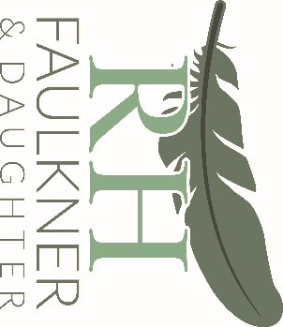

CREMATORIA PRICE INFORMATION

The information below gives the prices charged by crematoria within a 30-minute cortege journey of this funeral home

Standard Fee Attended Service  Redan Hill Chapel  Easthampstead Park Crematorium  Woking Crematorium  Guildford Crematorium | £1049.00  £1045.00  £1050.00  £1140.00
Unattended Service  Easthampstead Park Crematorium  Guildford Crematorium  Woking Crematorium  Redan Hill Chapel | £370.00  £410.00  £460.00  £350.00
Reduced Fee Attended Service  Easthampstead Park Crematorium  Guildford Crematorium  Woking Crematorium  Redan Hill Chapel | £684  Not Available  Not Available  Not Available
TERMS OF BUSINESS
Our Terms of Business include the following:
You must pay a deposit of 100% of the disbursements (third party payments) 50% of the Funeral Directors charges at the time of arranging the funeral.
The final balance must be paid 5 days before the funeral.
The following charges will be made for late payment: 3% interest after 30 days of the funeral date.

DISCLOSURE OF INTEREST

The ultimate owner of this business is RH Faulkner & Daughter Ltd – Paula Clinch and Nigel Clinch

We have no business or financial interest in a price comparison website which compares Funeral Director Services and/or Crematoria Services and their respective prices

We do not make any charitable donations

We do not make gratuity payments. These are other payments or gifts to third parties that are not related to a cost incurred or service provided by the third party, in connection with the arrangement of a funeral, or the operation of the funeral business.

